Homework 3

Assigned: September 23, 2024 (Monday)
Due: September 30, 2024 (Monday)

Problem 1: The ordinary tree without any constraint has a major problem (Discussed in class). Explain in detail the problem and the consequence by comparing linear and nonlinear data structures.
Skewed Unbalanced tree can have worst height of (n). Which is no beter than a linear data structure.

Problem 2: Compute the number of nodes in full binary tree with height k. Do following steps:
- Compute nodes at each level (same height). The root has height of 1, root children have height of 2, grand children have height of 3 and so on up to k. Draw a tree to show your work.
- Sum up the nodes at each level to get the total number of nodes in terms of k.
- Identify the number of internal and external nodes in term of k.
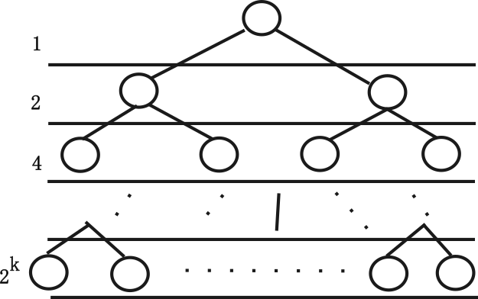
- Comment in few lines, on how things will change if we move from full tree to complete tree.
- Answer
Level 0: 1 = 2⁰
Level 1: 2 = 2¹
Level 2: 4 = 2²
Level 3: 8 = 2³
….
….
Level k-1: 2^{k-1}
Level k : 2^{k}

- Answer: 1+2+2²+2³ ----2^{k} = 2^{k+1} -1
- Answer:
  - Internal nodes = 2^{k} -1
  - External Nodes = 2^{k}
- Only last level changes with leaf nodes.

Problem 3: Draw a binary tree for a given Inorder, Postorder and Inorder Traversal.
Inorder: e,d,f,b,a,g,i,h,j,c,h
PreOrder: a,d,e,b,f,c,i,g,j,h
PostOrder: e,f,b,d,g,j,I,h,c,a

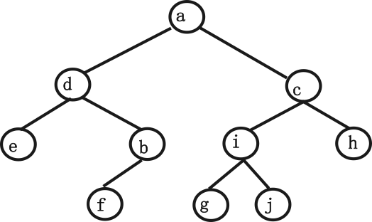

Problem 4: Explain Heaps? Write an algorithm to insert and delete elements from MAX Heap? Max Heaps have a total order with root node greater than the children at each subtree. Do the following:
(a) Insert the following element in null heap: 23, 45, 32, 16, 14, 17, 31, 87, 1, 54.
(b) After inserting the above elements, delete three elements from the heap one by one.
Show the diagram of heap after every insertion and deletion operation.

Please work this out
Problem 5: Write an algorithm for Heap Sort? Sort the following using Heap Sort:
21,32,16,2,15,87,67,3,54

Please work this out

